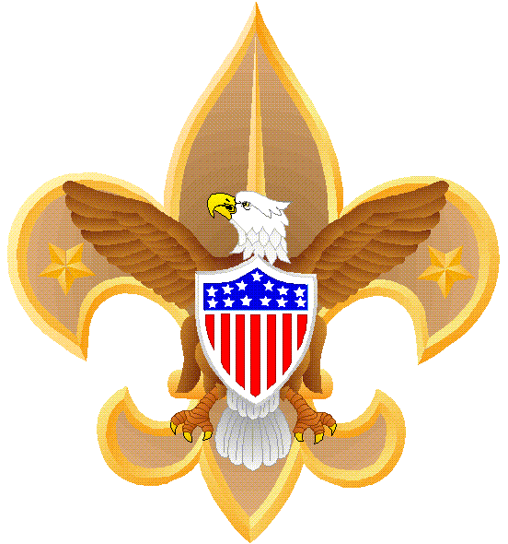 TROOP 442 GUIDE
FOR
MERIT BADGE COUNSELORS
September 8, 2010

Overview: Thank you for volunteering to be a merit badge counselor! You will have an enormous impact on our scouts and may influence them to enter a certain profession or take up a new hobby. This guide discusses how to be an effective merit badge counselor and includes official Boy Scout policies, Troop 442 emphasis items, and my experience.

Discussion: One of the best parts of scouting is the feeling of accomplishment when one earns a merit badge (MB), not to mention all a scout learns from completing the MB requirements. MBs also teach scouts goal setting, responsibility, dedication, meeting deadlines, the importance of being organized, how to study, teamwork, and how to interact with adult leaders. MBs are also required to progress beyond First Class.

- Before you become a MB counselor: You must be a registered adult leader in the troop, register as a MB counselor, and complete the Youth Protection training via the troop website (http://www.bactroop442.org/). Also, complete a “Prospective MB Counselor Survey” and consider6 counseling 3-6 MBs.

- Training as a MB counselor: Troop 442 conducts a 30 minute training session for new counselors which includes a folder with important information.
  - Please read “How to Earn Merit Badges” and the “Troop 442 Guide for Merit Badge Counselors.” These are in the folders.

- Conducting individual MB sessions: The troop uses a dual-track approach:
  - Every two months beginning 1 Nov we will schedule classes for two or three merit badges after the Tuesday night troop meetings.
    - Periodically we will host a “MB Academy” night after the troop meeting in which we will have 4-6 MB classes, some of which will be used to complete partial MBs.
  - Scouts can always contact merit badge counselors to complete badges individually (but scouts must be with another adult or another scout).

- Teaching MB classes: If you elect to teach MB classes, we recommend you develop a 1-2 page plan. Samples are included in your folder. Scouts and parents have often commented on how useful these short plans are and how they have made earning MBs easier without diluting the requirements.

- Teaching techniques: We recommend you follow a few tips to make your MB a meaningful experience for scouts:
  - Direct the scouts to read the MB pamphlet and complete a MB worksheet which can be downloaded from the troop website.
  - Discuss the requirements, and when they are ready to answer them, hold them accountable. You will be surprised how many scouts try to “snow” a counselor. It will be very obvious if they are prepared.
  - Group sessions are useful because scouts can learn from each other.
    - Ask them many questions to keep their attention and interest.
    - Divide the class in half and have Q&A contest with them.
  - In some cases a multiple choice test may be appropriate. I used this during the merit badge academy for Citizenship in the World. Out of 40 scouts, only 3 failed.
  - Field trips are useful not only to meet certain requirements but also to make a MB meaningful and fun. Field trips may require a tour permit—see the troop committee chairman for details.
  - Scouts always enjoy handouts such as a short article, flyer, brochure, etc. For the Citizenship in the World MB we gave out travel pamphlets provided by the Japanese consulate in Houston. Scouting magazine and the BSA website are great sources for articles.

- Standards: The high standards of scouting, especially in Troop 442, are reflected in this fact: only 4% of all scouts earn Eagle.
  - MB counselors can neither add requirements nor can they water them down. However, all scouts have different abilities, so use your judgment to determine if a scout has met all the requirements.
  - After conducting six MB classes this year, I found that the average percentage of scouts who actually complete MBs is about 60%.
  - Scouts must show some initiative to complete these. Don’t chase them down, but if they have only one or two requirements left, I do remind them and their parents how close they are to finishing.

- Blue cards: When a scout begins a MB they get a blue card from the merit badge coordinator. The scoutmaster signs it before the scout begins the MB and when the scout completes it. In your training folder there is an example of a blue card. When a scout completes all requirements, fill in the blue card. Give one part to the scout for their records, keep your portion, and give the MB coordinator the last part. He/she will then give this to advancement chair to be recorded in Troopmaster.

Conclusion: Thanks very much for volunteering to be a MB counselor. Enjoy this great part of scouting and have fun!

Phil Bossert, Troop 442 Merit Badge Coordinator
(281) 996-1019 bossertpab@aol.com

