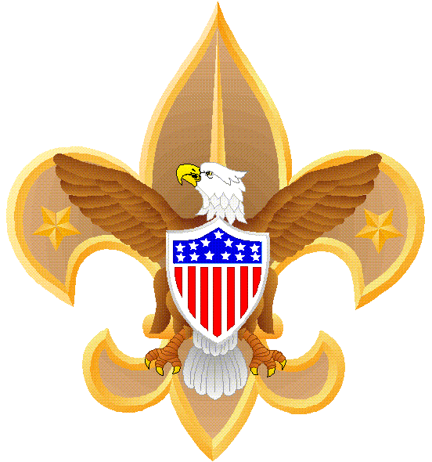 HOW TO EARN MERIT BADGES
Phil Bossert & Anita Shorosky
701 Woodview Drive, Friendswood, TX 77546
(281) 996-1019 bossertpab@aol.com
September 8, 2010

Overview: This handout discusses how to earn merit badges the correct way and was prompted by my experiences at the 22 September Merit Badge Academy. During that event I was shocked at how unprepared some scouts were.

Discussion: One of the best parts of scouting is the feeling of accomplishment when one earns a merit badge (MB), not to mention all a scout learns from completing the MB requirements. Here are some points on how to earn a MB the correct way:

- First, decide on which badge you want to earn and when. A scout can earn a MB at any rank, but I recommend new scouts wait until they become a Tenderfoot to attempt a merit badge and to select a non-Eagle required one. A new scout might have a bad experience if their first MB is Lifesaving or Personal Management!
  - Troop 442 will begin scheduling key merit badges on a regular basis, and we will normally conduct these classes after the regular troop meetings. The weekly troop e-mail updates will have specific information.

- Buy or borrow a MB book and read it! You can use the troop library or buy a book at the scout shop at 1300 Clear Lake Blvd in Clear Lake (call them first at (281) 282-6067 for their hours, directions, and if they have the MB book in stock). Also, download the latest MB worksheet from http://usscouts.org/usscouts
  - A good way to stay organized is to use a pocket folder to keep your requirements, worksheet, and other information together.

- Get a counselor. See the troop MB coordinator about getting a counselor. Talk to him/her and get recommendations on how to complete the requirements. You will be surprised how many MB counselors have developed quick yet effective methods to accomplish some of the more difficult requirements.
  - Make sure you get a blue card from the MB coordinator!
  - You do not have to wait for the Troop’s MB classes to accomplish a MB. Many scouts do these MBs individually.
  - Remember, counselors cannot add requirements nor “water them down.”

- After you have obtained a MB book, downloaded a MB worksheet, and talked to a MB counselor, begin completing the worksheet and maintain a dialogue with your counselor.
- As you complete the requirements, make an appointment with your counselor to review these. Remember, when you meet with a counselor you must have another scout or adult present.

- Have fun! In their haste to become an Eagle before they turn 14, some scouts forget that a huge part of scouting is simply to have fun. Pace yourself on these merit badges. And remember, many MB counselors like to include field trips and guest speakers to make your MB experience even more meaningful.
  - This year alone scouts have visited the Coast Guard Station at Ellington Field while working on the Aviation MB, they have visited the Johnson Space Center for the Space Exploration MB, attended a Friendswood City Counsel meeting for the Citizenship in the Community MB, and even heard from the assistant city manager of Friendswood after a troop meeting. So remember to have FUN!

- When you complete the MB, your counselor will sign off the requirements on your blue card and give to you. Then give it to the MB coordinator who will complete it and give you a section of it—SAVE IT in a safe location. Many scouts maintain a notebook for these blue cards.

- Check your records. Periodically the troop advancement chair will e-mail you your records. Make sure your MBs are reflected in these records.

- If you get a partial, make sure to complete remaining requirements within a few months. The longer you wait, the less your chances of completing a MB.

- Until you earn Eagle, you should always be working on a MB and planning ahead for the next one.
  - If you are too busy, try this: add up all the hours you spend watching TV, using your computer, listening to iPods, and playing electronic games each week. Then multiply that number by just 10%. If you dedicate that final number, let’s say it turned out to be 2 hours, to working on merit badges, you’ll be amazed how quickly your merit badge sash will fill up.

- Even after you earn Eagle, you can attain Eagle Palms for every five additional MBs. There are bronze, silver, and gold Eagle Palms.

Conclusion: Scouts in Troop 442 complete merit badges the old fashioned way—they earn them. The tremendous feeling of accomplishment after a scout has set a goal, planned, organized, studied hard, learned something new, met yet another role model, and taken one more step towards Eagle is priceless. Many teachers, doctors, police officers, lawyers, civic leaders, fireman, engineers, pilots, astronauts, writers, and others first got interested in their professions while earning merit badges.

Enjoy this great part of scouting, work hard, and have fun!
Mr. Phil Bossert, Troop 442 Merit Badge Coordinator

